19. 5G network slicing environment
AIM :
To simulate a 5G network slicing environment by dynamically allocating bandwidth to eMBB, URLLC, and mMTC slices based on priority, and to analyze their throughput and latency performance.
THEORY :
5G network slicing enables the same physical network to be divided into multiple virtual networks, each optimized for a specific service type.
The three major slice types are eMBB (enhanced Mobile Broadband) for high data rates, URLLC (Ultra-Reliable Low Latency Communication) for mission-critical applications, and mMTC (massive Machine Type Communication) for IoT devices.
Slices receive bandwidth and resources according to priority, and their performance is measured using throughput (based on spectral efficiency) and latency for each service.
PROCEDURE :
- Define total available bandwidth and slice requirements for eMBB, URLLC, and mMTC.
- Assign priority weights to slices and compute bandwidth allocation dynamically.
- Calculate throughput for each slice using spectral efficiency and allocated bandwidth.
- Simulate latency for each slice reflecting realistic 5G service behavior.
- Display allocated bandwidth, throughput, and latency values for all slices.
- Plot bar graphs for throughput and latency comparisons among the slices.
- Plot a pie chart showing the dynamic bandwidth distribution across slices.

PROGRAM :
clear; clc; close all;

%% Total available bandwidth (MHz)
BW_total = 100;

%% Slice Requirements
% eMBB: High throughput
% URLLC: Ultra low latency, high priority
% mMTC: Large number of devices, small packets

req_eMBB = 50; % Required Mbps
req_URLLC = 20; % Required Mbps
req_mMTC = 10; % Required Mbps

priority = [2 3 1]; % 1=low, 3=high priority (URLLC > eMBB > mMTC)

%% Dynamic Bandwidth Allocation
BW_alloc = zeros(1,3);
req = [req_eMBB req_URLLC req_mMTC];

% Weighted allocation based on priority
priority_weights = priority ./ sum(priority);
BW_alloc = BW_total * priority_weights;

%% Compute Throughput (T = BW * spectral efficiency)
SE_eMBB = 6; % bits/s/Hz
SE_URLLC = 4;
SE_mMTC = 1;

th_eMBB = BW_alloc(1)*1e6 * SE_eMBB / 1e6;
th_URLLC = BW_alloc(2)*1e6 * SE_URLLC / 1e6;
th_mMTC = BW_alloc(3)*1e6 * SE_mMTC / 1e6;

%% Latency Simulation (URLLC minimum)
lat_eMBB = 20 + rand*10; % ms
lat_URLLC = 1 + rand*0.5; % ms
lat_mMTC = 50 + rand*20; % ms

%% Print Results
fprintf("\n===== Network Slicing Simulation Results =====\n");
fprintf("Allocated Bandwidth (MHz): eMBB=%.2f, URLLC=%.2f, mMTC=%.2f\n", BW_alloc(1), BW_alloc(2), BW_alloc(3));
fprintf("Throughput (Mbps): eMBB=%.2f, URLLC=%.2f, mMTC=%.2f\n", th_eMBB, th_URLLC, th_mMTC);
fprintf("Latency (ms): eMBB=%.2f, URLLC=%.2f, mMTC=%.2f\n", lat_eMBB, lat_URLLC, lat_mMTC);

%% Plot Throughput Comparison
figure;
bar([th_eMBB, th_URLLC, th_mMTC]);
set(gca, 'XTickLabel', {'eMBB','URLLC','mMTC'});
ylabel('Throughput (Mbps)');
title('Slice-wise Throughput Performance');

%% Plot Latency Comparison
figure;
bar([lat_eMBB, lat_URLLC, lat_mMTC]);
set(gca, 'XTickLabel', {'eMBB','URLLC','mMTC'});
ylabel('Latency (ms)');
title('Slice-wise Latency Performance');

%% Plot Bandwidth Allocation
figure;
pie(BW_alloc, {'eMBB','URLLC','mMTC'});
title('Dynamic Bandwidth Allocation for 3 Network Slices');

OUTPUT :
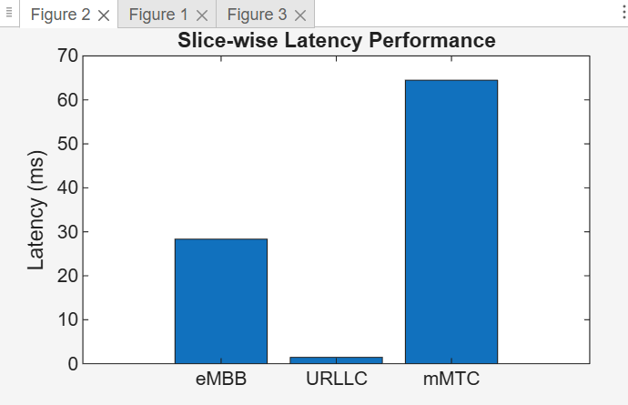
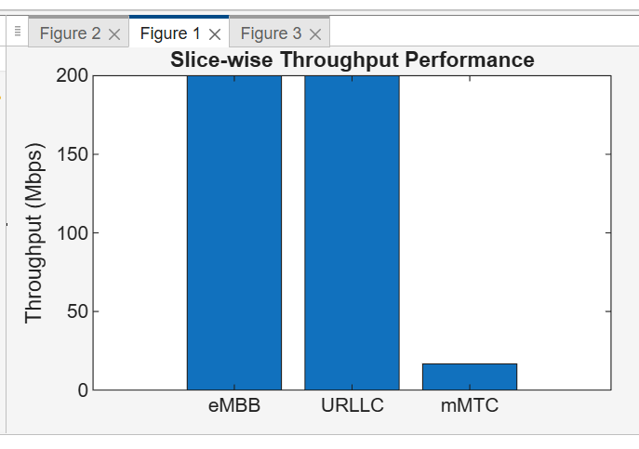

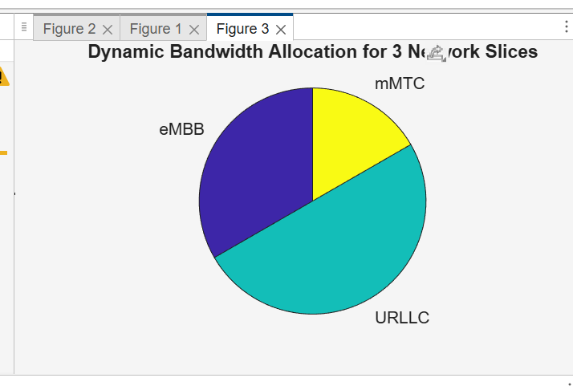
CONCLUSION :
URLLC receives higher priority and therefore gains more reliable and low-latency performance compared to other slices.
eMBB achieves high throughput due to greater spectral efficiency, while mMTC receives minimal resources suited for massive low-rate devices.
The simulation confirms that 5G network slicing effectively allocates resources based on service requirements to optimize overall network performance.

